Apps UP Returns with Over US$1 Million Prize Money
HUAWEI Developers invites talented developers from around the world to put their skills to the test with the launch of Huawei Global App Innovation Contest (Apps UP) 2022, with registrations now open globally. With this year’s theme "Together We Innovate”, Apps Up has dedicated an impressive prize pool of over US$1 million globally as an incentive for app developers to create seamless, smart and innovative apps that bring extraordinary digital experiences for consumers.
Apps Up is now on its 3rd year of driving innovation, building on 10,000 submissions from almost 10,000 developers since 2020 and continues to provide support, opportunities and a platform for developers to realise their dreams on a global stage.
"This contest is now in its third consecutive year. We hope to pool the skills of developers globally to bring smart apps and experiences across Huawei devices to more consumers worldwide, for a digital future now,” said Wang Yue, President of Huawei Consumer Cloud Service Application Ecosystem BU.
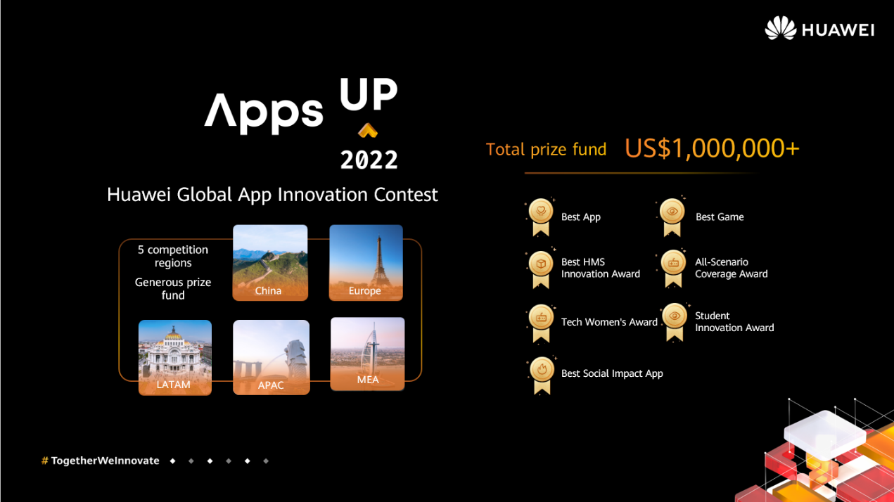
Apps Up 2022 brings 7 award categories across 5 competition regions
The contest, launched in Europe, Asia Pacific, Latin America, Middle East & Africa, and China simultaneously, is divided into the following stages: Registration & Submission, Preliminary, Public Review, and Regional Finals.

Along with the Best App, Best Game, Best Social Impact App, All-Scenario Coverage Award, and Tech Women's Award, there is also the Student Innovation Award, which recognises outstanding student developers who showcase innovative works enriched with the Seamless AI experience, as well as Honorable Mention awards that are dedicated to impressive submissions.

Apps Up 2022 sees new exciting incentives for contestants
This year's contestants can also get their hands on a range of exciting incentives, including the chance to have their app promoted on AppGallery.

Aligning with its Seamless AI life strategy, Huawei has released a number of HMS capabilities that support an array of devices continually providing a better AI life experience for users across scenarios.

Huawei's HMS ecosystem is dedicated to empowering developers. Apps UP, as one of the many available platforms for developers to join the HMS ecosystem, will inspire developers to create more ground-breaking AI life apps and services in a number of fields, for a worldwide audience.

Enter today and find out more at:
https://developer.huawei.com/consumer/en/activity/digixActivity/digixdetail/201655277856046898

Join the Huawei Developer Discord channel for all Apps UP 2022 updates and news! https://discord.com/invite/n6DTutkHKh

-Ends–

About HUAWEI Mobile Services (HMS)
HUAWEI Mobile Services is part of Huawei Consumer Business Group which aims to provide a complete mobile experience to users globally. As of 31st December 2021, HUAWEI Mobile Services covers 730 million users in over 170 countries, enabling smart living for every Huawei device user.

About HUAWEI Consumer BG

HUAWEI’s products and services are available in more than 170 countries and are used by a third of the world’s population. Fourteen R&D centres have been set up in Germany, Sweden, Russia, India and China. HUAWEI Consumer BG is one of HUAWEI’s three business units and covers smartphones, PC and tablets, wearables and cloud services, etc. HUAWEI’s global network is built on almost 30 years of expertise in the telecom industry and is dedicated to delivering the latest technological advances to consumers around the world.

For more information, please visit https://www.huawei.com/en

